Online Payments Fraud Detection using Machine Learning. 1.INTRODUCTION
This project, titled “Online Payments Fraud Detection using Machine Learning,” is developed as part of the SmartBridge Virtual Internship Program. The objective of this project is to detect fraudulent online payment transactions using machine learning techniques based on transaction and user behavior data.
In today’s digital economy, online payments have become an essential part of daily life. However, the rapid growth of digital transactions has also increased the risk of fraudulent activities such as unauthorized transactions, identity theft, and payment manipulation. Detecting fraudulent transactions in real-time is challenging due to the large volume of transactions and the evolving nature of fraud techniques.
This project addresses this challenge by applying artificial intelligence to analyze historical transaction data and identify suspicious patterns that indicate fraud. By leveraging machine learning algorithms, the system predicts whether a transaction is Fraudulent or Legitimate, helping banks, financial institutions, and payment platforms reduce financial losses and enhance security.

1.2 Purpose
The main purpose of this project is to apply theoretical knowledge of artificial intelligence and machine learning to develop a practical solution for detecting fraudulent online payment transactions based on transaction-related parameters.
The project enables understanding of data preprocessing, feature engineering, machine learning model training, and integration of the prediction model into a functional web application using Python and related technologies.
The project also provides hands-on experience in working with real-world financial transaction datasets and building an end-to-end fraud detection system. It enhances analytical thinking, risk assessment capability, and technical skills in machine learning, data analysis, and cybersecurity-focused application development.

2. IDEATION PHASE
2.1 Problem Statement
In the modern digital payment ecosystem, online transactions are increasing rapidly. However, this growth has led to a significant rise in fraudulent activities such as credit card fraud, identity theft, and unauthorized digital payments.
Fraudulent transactions are influenced by multiple dynamic factors such as transaction amount, time of transaction, device information, location, transaction frequency, and user behavior patterns. Due to the complexity and volume of transactions, detecting fraud manually is inefficient and unreliable.
Most traditional fraud detection methods rely on rule-based systems, which may fail to detect new and sophisticated fraud patterns. Inaccurate detection can lead to financial losses, customer dissatisfaction, and reputational damage for financial institutions.
Therefore, there is a strong need for an accurate, real-time, AI-based fraud detection system that can analyze historical transaction data and classify transactions as Fraudulent or Legitimate to support secure digital payment processing and reduce financial risk.

2.2 Empathy Map Canvas
The Empathy Map Canvas helps in understanding the users such as banks, payment gateway providers, and customers, along with their challenges and expectations regarding online payment security.
What the User Thinks
• Wants transactions to be secure and fraud-free
• Expects accurate detection without blocking genuine transactions
What the User Feels
• Concerned about financial loss and data theft
• Confident when strong fraud detection systems are in place

What the User Says
• “Online fraud is increasing rapidly.”
• “I need a reliable system to protect digital payments.”

What the User Does
• Monitors transaction history regularly
• Uses traditional rule-based fraud detection systems

User Pain Points
• High financial loss due to fraud
• False positives blocking genuine transactions
• Lack of real-time fraud detection systems

User Needs
• Accurate machine learning–based fraud detection
• Real-time transaction monitoring
• Secure and reliable payment system
• Clear fraud probability score and alerts

2.3 Brainstorming
During the brainstorming phase, different approaches were discussed to solve the challenge of fraud detection. These included traditional statistical analysis, rule-based fraud detection systems, anomaly detection techniques, and machine learning–based classification models using historical transaction data.
After evaluating all options, the machine learning–based approach was selected because it offers higher accuracy, adaptability to new fraud patterns, and scalability for processing large volumes of transaction data.
Machine learning models can learn from past fraudulent and legitimate transaction data, identify hidden patterns, and continuously improve performance, making them suitable for real-time financial fraud detection systems.

3. REQUIREMENT ANALYSIS
The Customer Journey Map explains the sequence of steps followed by the user while interacting with the online fraud detection system.
The journey begins when a customer initiates an online payment transaction. The system captures transaction-related parameters such as transaction amount, transaction time, location, device type, payment method, and account history.
The input data is processed by the trained machine learning fraud detection model. After processing, the system predicts whether the transaction is Fraudulent or Legitimate along with a probability score.
If the transaction is identified as fraudulent, the system may block the transaction or trigger an alert for further verification. This process ensures secure payment processing and protects users from financial loss.

3.2 Solution Requirements
This section describes the functional and non-functional requirements of the proposed Online Payments Fraud Detection System.
Functional Requirements
• The system should capture transaction-related input parameters (e.g., transaction amount, time, location, device type, payment method, account age, transaction frequency).
• The system should validate transaction data before processing.
• The system should preprocess the input data (encoding, scaling, handling missing values).
• The system should use the trained Machine Learning model to classify transactions as Fraudulent or Legitimate.
• The system should display the prediction result along with fraud probability score.
• The system should trigger alerts or block transactions if fraud probability exceeds a threshold.
• The system should handle invalid or incomplete transaction data properly.
• The system should store transaction records and prediction results in the database.
• The system should provide real-time prediction within seconds.

Non-Functional Requirements
• The system should have a simple and secure user interface.
• The system should provide fast response time for real-time fraud detection.
• The system should ensure high accuracy and low false positive rate.
• The system should securely handle sensitive financial and user data.
• The system should be available and operational 24/7.
• The system should support high transaction volumes without performance degradation.
• The system should be scalable and modular to allow model retraining and updates.

3.3 Data Flow Diagram
The Data Flow Diagram (DFD) explains how data moves within the fraud detection system during the transaction process.
When a user initiates an online payment, the transaction details are sent to the system. The input data is forwarded to the preprocessing module, where it is validated, cleaned, encoded, and scaled.
The processed data is then passed to the trained Machine Learning fraud detection model. The model analyzes the transaction and predicts whether it is Fraudulent or Legitimate along with a probability score.
Finally, the prediction result is sent back to the payment system interface. If the transaction is legitimate, it is processed successfully. If it is fraudulent, the system blocks the transaction or generates a security alert.
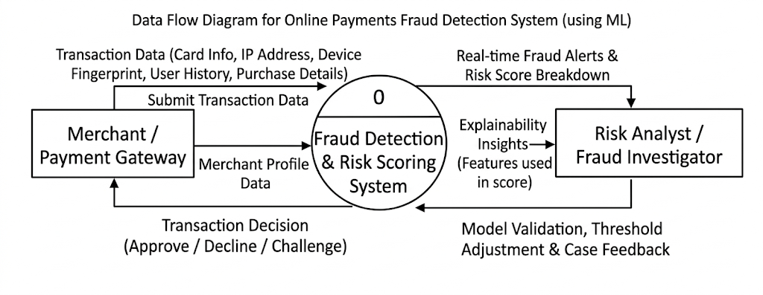
3.4 Technology Stack
The following technologies are used in the development of this project:
•ProgrammingLanguage:Python
•Framework:Flask
• Machine Learning Library: Scikit-learn (for building and training the fraud detectionmodel)
•DataProcessingLibraries:Pandas,NumPy
•Model Storage: Pickle (.pkl file for saving the trained model)
•FrontendTechnologies:HTML,CSS
•Database (Optional): MySQL / SQLite (for storing transaction and prediction records)
• Development Tools: VS Code, Git, GitHub

4. PROJECT DESIGN
4.1 Problem–Solution Fit
The proposed Online Payments Fraud Detection System effectively addresses the growing issue of fraudulent digital transactions by using Machine Learning techniques to detect suspicious payment activities in real-time.
The system collects relevant transaction data such as transaction amount, time, location, device information, and user behavior patterns. It preprocesses the data and applies a trained Machine Learning classification model to generate accurate fraud detection results.
This automated solution reduces dependency on traditional rule-based systems, minimizes financial losses, improves detection accuracy, and ensures secure online payment processing.
The system is suitable for real-world applications such as banking systems, payment gateways, e-commerce platforms, fintech applications, and digital wallet services where secure transaction processing is critical.

4.2 Proposed Solution
The proposed solution is a Machine Learning–based web application that enables financial institutions and payment platforms to detect fraudulent transactions based on transaction-related parameters.
The working of the system is described below:
• The user initiates an online payment transaction by providing transaction details such as transaction amount, transaction time, payment method, device type, location, and account-related information.
• The system captures, validates, and preprocesses the transaction data (handling missing values, encoding categorical variables, scaling numerical features).
• The trained Machine Learning model processes the transaction data and predicts whether the transaction is Fraudulent or Legitimate.
• The predicted result along with the fraud probability score is generated and displayed to the system administrator or used to automatically approve or block the transaction.
The system is designed to be secure, fast, and scalable, ensuring efficient fraud detection without affecting genuine customer transactions.

4.3 Solution Architecture
The solution architecture explains the overall structure of the Online Payments Fraud Detection System and how different components interact with each other.
The architecture consists of the following components:
• User Interface:
Accepts transaction-related input parameters (such as transaction amount, time, location, device type, payment method, account history, etc.) and displays the fraud detection result along with the probability score.
• Data Collection Module:
Captures transaction details in real-time when a user initiates an online payment.
• Preprocessing Module:
Validates, cleans, encodes, scales, and formats the transaction data before sending it to the prediction model.
• Machine Learning Fraud Detection Model:
Processes the preprocessed transaction data and predicts whether the transaction is Fraudulent or Legitimate using a trained classification algorithm such as Logistic Regression, Decision Tree, Random Forest, or XGBoost.
•Decision&AlertModule:
Based on the predicted fraud probability, the system either approves the transaction, blocks it, or triggers an alert for manual verification.
•OutputModule:
Displays the final transaction status and fraud probability score clearly to the administrator or system dashboard.
These components work together in a sequential and integrated manner to ensure accurate, fast, and reliable fraud detection while maintaining secure and seamless digital payment processing.
.
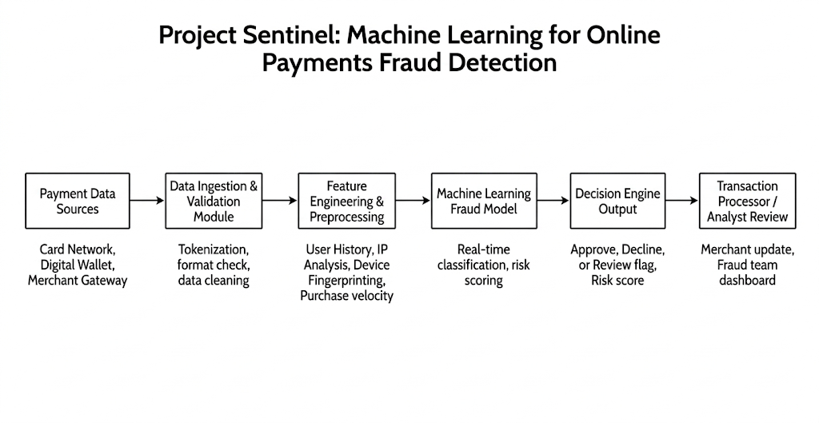
5. PROJECT PLANNING AND SCHEDULING
Project planning plays an important role in completing the project in a systematic and organized manner. The Online Payments Fraud Detection System was planned and executed in multiple phases to ensure smooth development and timely completion.
The planning of the project was carried out in the following stages:
• Requirement Analysis: Understanding the problem of detecting fraudulent online transactions, defining project objectives, and identifying system requirements such as transaction parameters (amount, time, location, device type, payment method), fraud detection accuracy, response time, and security measures.
• Design Phase: Designing the system architecture and defining the interaction between components such as the user interface, data collection module, preprocessing module, machine learning model, and output/alert module.
• Development Phase: Implementing the web application using Python and Flask, developing the fraud detection classification model using Scikit-learn, training it on historical transaction data, and integrating the trained model with the web interface.
• Testing Phase: Testing the system for correct fraud predictions, input validation, real-time response generation, alert triggering, and overall system stability. Model performance metrics such as accuracy score, confusion matrix, precision, recall, and classification report were evaluated.
• Deployment Phase: Running the application locally, verifying end-to-end transaction flow, and preparing the system for future enhancements such as cloud deployment, API integration, or real-time payment gateway implementation.
This phased approach helped in managing the project efficiently, ensuring structured development, and reducing errors during implementation.

5.2 Project Scheduling
The project schedule was planned to complete all activities within a total duration of 20 days, as per the SmartBridge internship timeline. Each phase was carefully allocated time to ensure proper implementation, testing, and documentation of the project.
The scheduling of the Online Payments Fraud Detection System project is shown below:
Phase | Activity | Duration
Phase 1 | Requirement Analysis | 3 Days
Phase 2 | System Design | 3 Days
Phase 3 | Application Development | 7 Days
Phase 4 | Testing and Debugging | 4 Days
Phase 5 | Deployment and Documentation | 3 Days

6. FUNCTIONAL AND PERFORMANCE TESTING
Functional testing is performed to verify that all features of the Online Payments Fraud Detection System work according to the specified requirements.
The following functional tests were conducted:
• Verification of transaction input functionality: Ensuring that the system correctly captures transaction-related parameters such as transaction amount, time, payment method, location, device type, and account details.
• Validation of input data: Checking that the system properly validates inputs, handles missing or invalid values, and restricts incorrect data formats.
• Verification of model integration: Ensuring correct integration between the Flask web application and the trained Machine Learning fraud detection model.
• Verification of fraud prediction output display: Checking that the predicted transaction status (Fraudulent / Legitimate) and probability score are correctly generated and displayed.
• Alert and decision validation: Ensuring that fraudulent transactions trigger alerts or blocking mechanisms correctly.
• Error handling validation: Ensuring the system properly handles runtime errors and provides meaningful feedback messages.
All functional requirements were tested successfully, and the system performed as expected.

6.2 Performance Testing
Performance testing is conducted to evaluate the response time, efficiency, and stability of the Online Payments Fraud Detection System.
The system was tested for:
• Response Time of Fraud Detection: Measuring the time taken by the system to process transaction data and generate fraud predictions.
• Stability During Multiple Transactions: Testing the system’s ability to handle multiple transaction requests simultaneously without crashing or slowing down significantly.
• Smooth Interaction Between Web Interface and ML Model: Ensuring seamless communication between the Flask web application and the trained Machine Learning model.
• System Resource Usage: Monitoring CPU and memory usage during prediction to ensure efficient and optimized performance.
The results show that the system generates fraud predictions with minimal delay and provides a smooth and reliable user experience under normal usage conditions.

7. RESULTS
The Online Payments Fraud Detection System was successfully developed and tested using Python, Flask, and Machine Learning techniques. The system provides accurate and real-time classification of transactions as Fraudulent or Legitimate based on user-entered transaction parameters.
The application interface consists of:
• Input fields for entering transaction-related parameters such as transaction amount, time, location, device type, payment method, and account details
• A Submit / Verify button to initiate fraud detection
• A display section showing the transaction status (Fraudulent / Legitimate) along with the fraud probability score
When a user initiates a transaction and submits the details, the application sends the data to the backend. The preprocessing module validates, cleans, and encodes the transaction data before passing it to the trained Machine Learning classification model.
The model processes the transaction features and returns the predicted result with its fraud probability, which is displayed instantly on the web interface or used for automated transaction approval/blocking.
The results confirm that the system performs as expected and meets all the functional requirements defined in the project. Fraud predictions are generated quickly with minimal delay, ensuring secure and efficient online payment processing.

7.2 Output Screenshots
The output screenshots demonstrate the working of the Online Payments Fraud Detection System. The screenshots show:
• User-entered transaction values such as transaction amount, payment method, device type, and location
• Validation messages for incorrect or missing inputs
• The predicted transaction status (Fraudulent / Legitimate) displayed after submission
• The fraud probability score indicating the likelihood of fraud
These screenshots confirm that the system correctly captures transaction details, processes the data through the Machine Learning model, and displays accurate fraud classification results through the web interface.


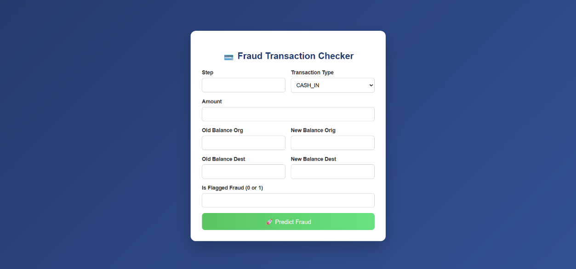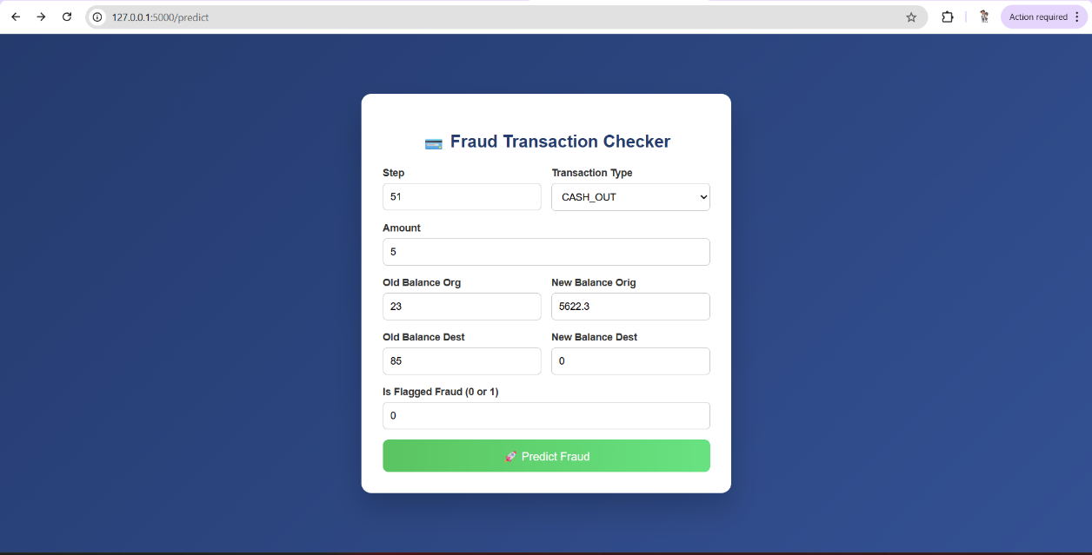

8. ADVANTAGES AND DISADVANTAGES

8.1 Advantages
The Online Payments Fraud Detection System provides several advantages that make it effective and practical for real-world financial applications:
• Easy-to-use and secure web interface
• Real-time fraud detection with minimal response time
• Accurate classification of transactions as Fraudulent or Legitimate
• Reduces financial losses caused by unauthorized transactions
• Scalable system design suitable for high transaction volumes
• Web-based application with simple deployment
• Enhances security in banking, fintech, and e-commerce platforms
• Provides fraud probability scores for better risk interpretation
• Reduces dependency on manual monitoring and rule-based systems

8.2 Disadvantages
Despite its advantages, the Online Payments Fraud Detection System has a few limitations:
• Prediction accuracy depends on the quality and volume of historical transaction data
• The model may not detect completely new or highly sophisticated fraud patterns without retraining
• False positives may occasionally block legitimate transactions
• Requires proper preprocessing and feature engineering for optimal performance
• Performance may vary depending on server configuration and system resources
• The model requires periodic retraining to maintain accuracy with evolving fraud trends

9. CONCLUSION
The Online Payments Fraud Detection System successfully demonstrates the practical application of Machine Learning techniques to detect fraudulent digital transactions based on transaction-related parameters. The project provides an efficient, secure, and user-friendly solution for identifying suspicious payment activities using a web-based interface built with Python and Flask.
The application delivers fast and reliable fraud predictions by processing inputs such as transaction amount, time, location, device type, and payment method. The system applies a trained classification model to generate transaction status (Fraudulent / Legitimate) along with probability scores, helping financial institutions reduce risk and protect users.
With a simple interface and structured backend integration, the project ensures smooth interaction between the payment system and the fraud detection model. The system can assist banks, payment gateways, fintech platforms, and e-commerce companies in enhancing transaction security.
Overall, the project meets all defined objectives and showcases the practical implementation of machine learning in cybersecurity and financial technology applications. It serves as a strong demonstration of technical skills and real-world problem-solving capability, making it suitable for academic and internship evaluation.

10. FUTURE SCOPE
The Online Payments Fraud Detection System can be further enhanced in the future to improve accuracy, scalability, and real-time capabilities. Some possible future enhancements include:
• Integration with real-time payment gateways and banking APIs
• Deployment on cloud platforms for global scalability and high availability
• Implementation of advanced Machine Learning and Deep Learning models (e.g., Neural Networks, XGBoost)
• Use of real-time anomaly detection algorithms for improved fraud identification
• Incorporation of behavioral biometrics and device fingerprinting
• Development of a mobile application version for fraud monitoring
• Implementation of interactive dashboards and data visualization for fraud analytics
• Continuous model retraining using live transaction data
These enhancements can make the system more intelligent, adaptive, and suitable for large-scale financial and banking environments.

11. APPENDIX
The complete source code of the Online Payments Fraud Detection System is maintained using GitHub for version control. The repository contains all application files, including:
• Backend application files (Flask – app.py)
• Frontend templates (index.html, verify.html)
• CSS styling files
• Machine Learning model file (model.pkl)
• Configuration and dependency files
• Project documentation
The version control system helps in tracking changes, managing updates, and maintaining proper documentation throughout the development process.
The repository provides all the necessary files required to understand, execute, and further enhance the project.
GitHub Repository Link: https://github.com/tulasimahalaxmisomaraju/Online-Payments-Fraud-Detection-using-Machine-Learni

Repository Contents
The GitHub repository for the Online Payments Fraud Detection System contains the following files:
• app.py – Main Flask application file that handles routing, transaction input, and fraud prediction logic
• templates/index.html – Homepage of the application
• templates/verify.html – Transaction verification page for entering payment details and viewing results
• static/style.css – CSS file for UI styling
• model.pkl – Trained Machine Learning fraud detection model
• requirements.txt – List of required Python dependencies
• .gitignore – Excludes unnecessary or sensitive files from version control
• README.md – Project description, setup instructions, and usage guidelines
Using GitHub helped in maintaining proper version control, tracking changes efficiently, and following professional software development practices throughout the project lifecycle.

11.2 Security Implementation
The Online Payments Fraud Detection System was developed with proper security considerations to ensure safe handling of sensitive financial data and system resources.
The following secure practices were implemented:
• Sensitive configuration details (such as secret keys or database credentials) are stored using environment variables
• A .env file is used to securely manage configuration values
• The .env file is excluded from GitHub using .gitignore to prevent exposure of sensitive data
• No secret keys or confidential information are hardcoded in the source code
• Input validation is implemented to prevent invalid or malicious transaction inputs
• Basic error handling mechanisms are included to prevent system crashes
These practices ensure secure handling of sensitive financial information, protect the application from common vulnerabilities, and maintain professional software development standards.

11.3 Project Demo
A working demo of the Online Payments Fraud Detection System was recorded to demonstrate the functionality and output of the application.
Project Demo Video Link: https://drive.google.com/file/d/1CI0PdA6gYVbyY4bvSD5F2bHVujaNX4Wt/view?usp=sharing
The demo video showcases:
• User entering transaction-related input parameters such as transaction amount, payment method, location, and device type
• Clicking the “Verify” or “Submit” button to initiate fraud detection
• Display of transaction status (Fraudulent / Legitimate)
• Display of fraud probability score for better risk analysis
• Final output displayed clearly on the web interface
The demo confirms that the system works as expected and successfully performs fraud detection with a smooth and secure user interface.

11.4 Team Details
• Internship Program: SmartBridge Virtual Internship
• Project Title: Online Payments Fraud Detection using Machine Learning
• Team Size: 4
Team Leader: Tulasi Mahalakshmi Somaraju
Team Members:
- Patta Tejeswararao
- Ungarala Hima Satya Sri
- Veera Raghava Reddy Chityal

11.5 References
The following resources were referred to during the development of this project:
• Python Programming Language Documentation
• Flask Framework Documentation
• Scikit-learn Library Documentation
• NumPy and Pandas Libraries
• Machine Learning Research Papers and Online Tutorials
• Fraud Detection and Cybersecurity Learning Resources

